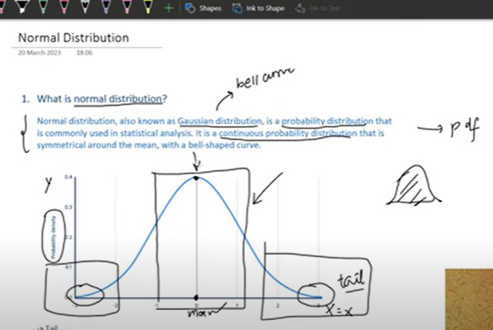

**2 parameters- mean and sd**

**Mean: center of distribution**

**SD: spread of distribution**

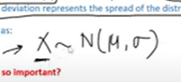

**Random variable belongs to Normal distribution at mean and sd**

**Why its so imp?**

**Commonality in nature , many follow normal distribution(heights of people, weights, cgpa)**

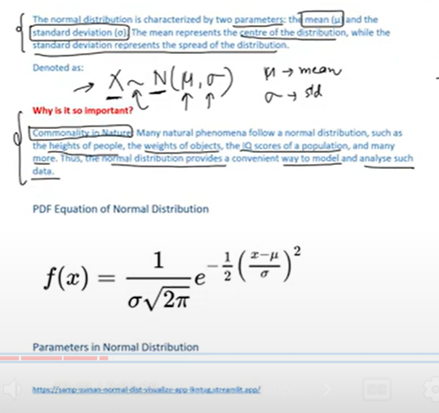

**Mean and sd impact on Normal distribution**

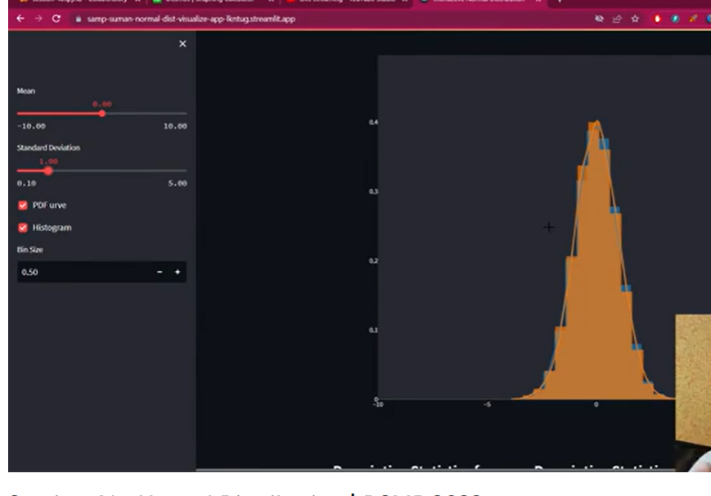

**Mean zero, sd =1**

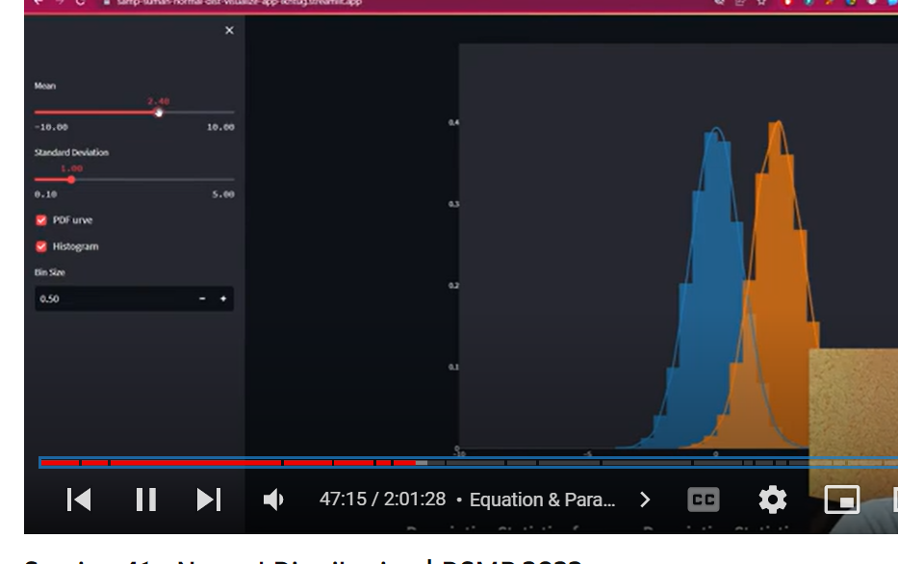

**When mean changes graph moves on x axis**

**Blue graph is constant(we have drawn to compare)**

**Orange – actual graph**

**When we change sd :**

**Sd increases**

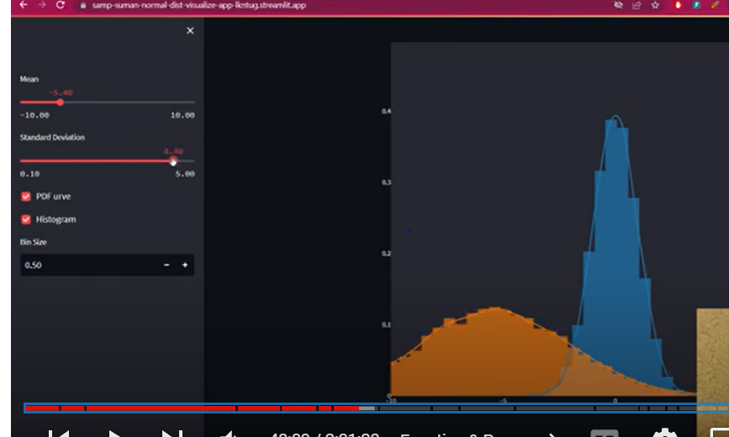

**Spread increases**

**Where as when sd decreases :**

**Spread decreases**

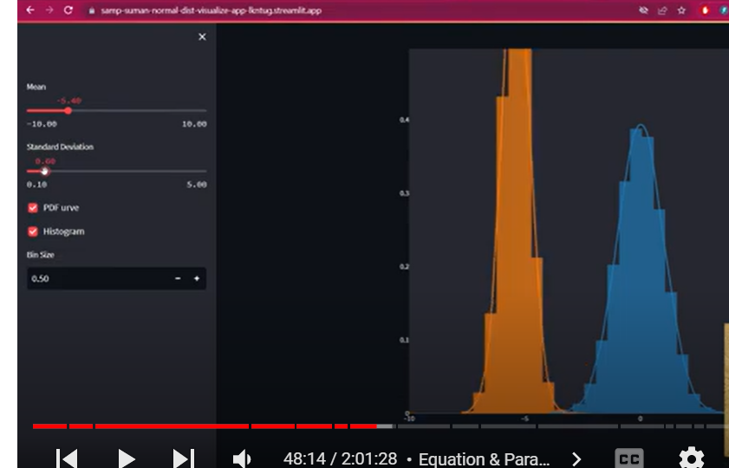

**Intuition of equastion:**

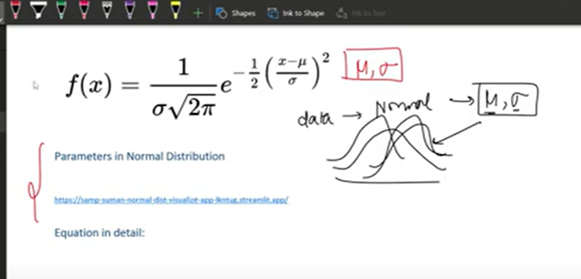

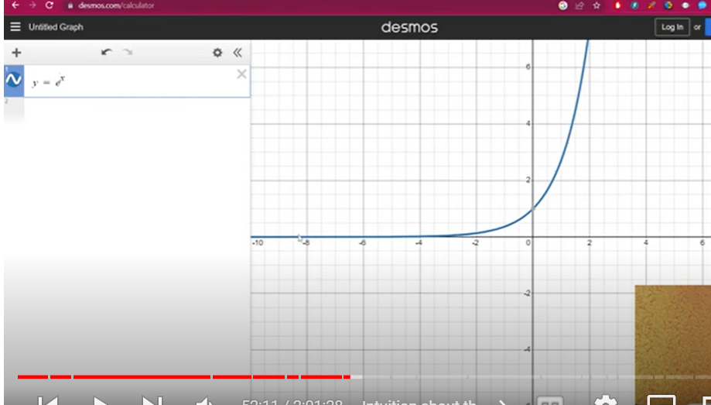

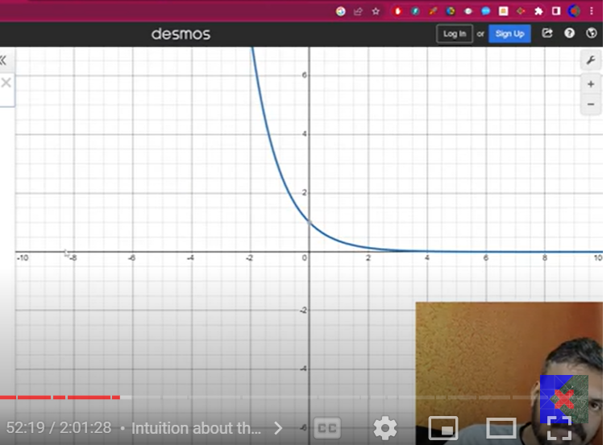exponential graphs

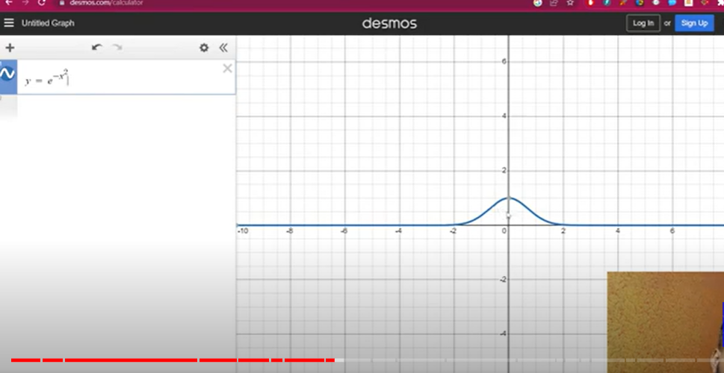

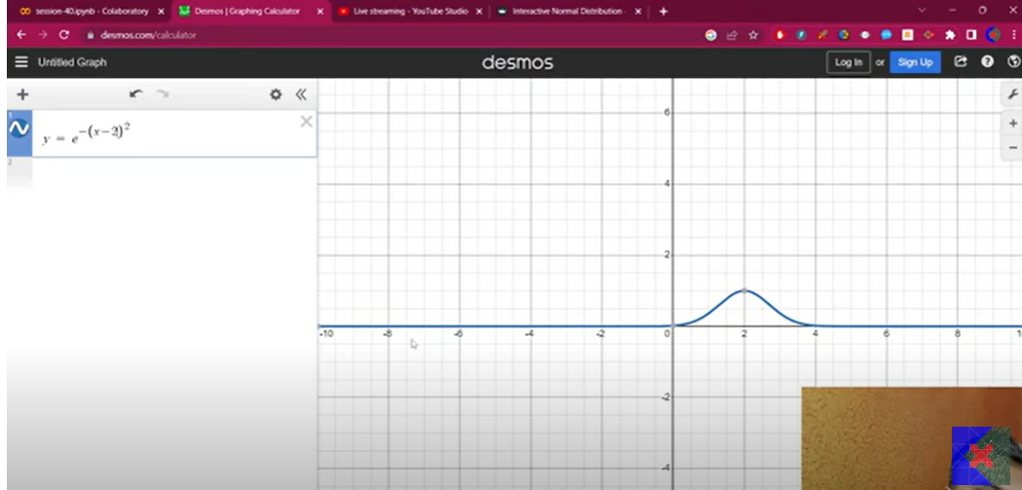

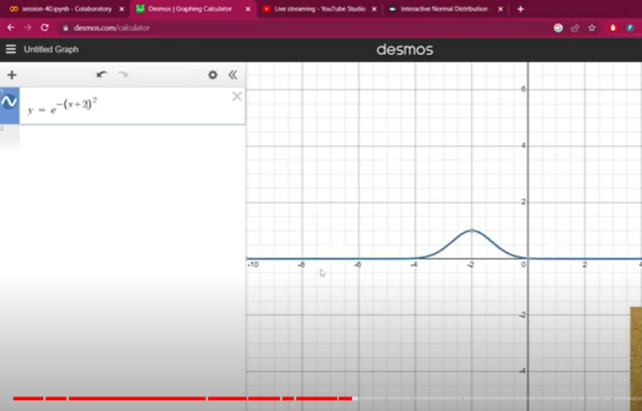

By above equ we get normal distribution

Now we are scalling

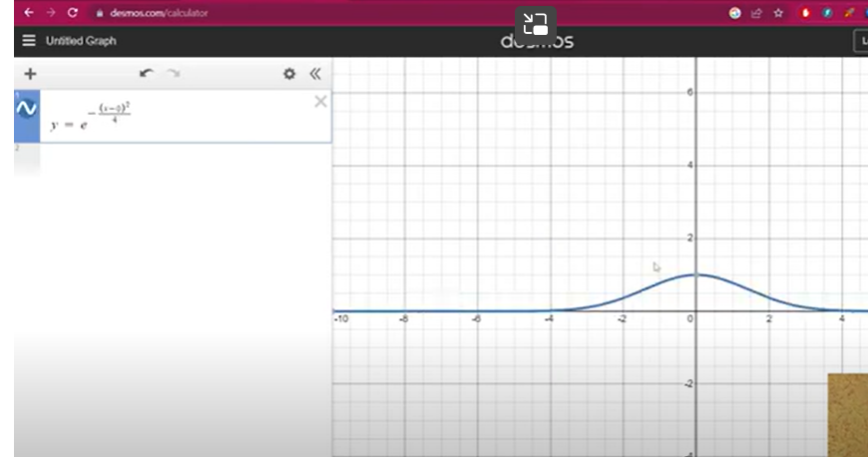

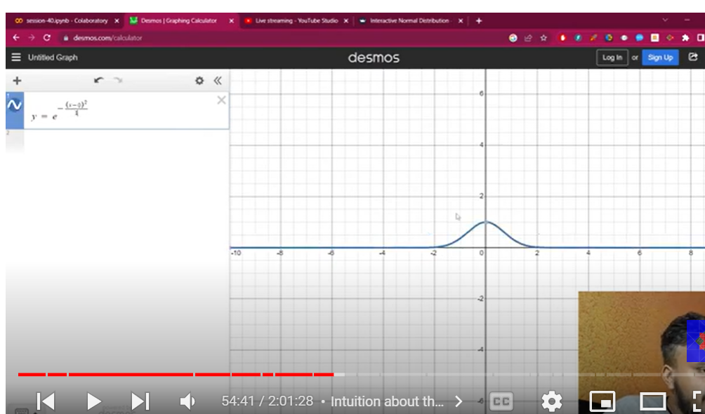

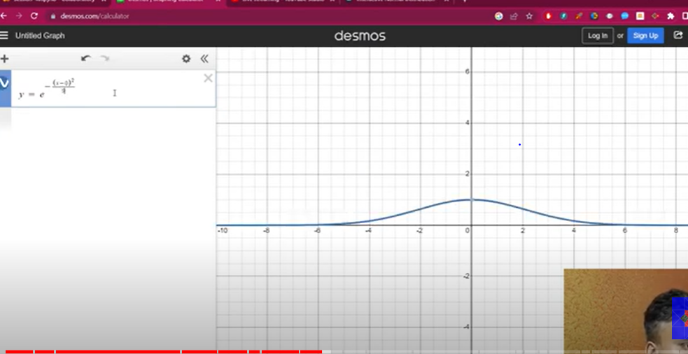

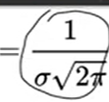

**This entire area is =1**

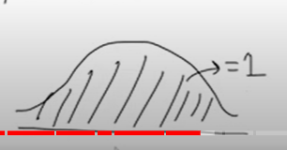

**By using integration with** **this formula can calculate area**

**Actual essence of equation is**

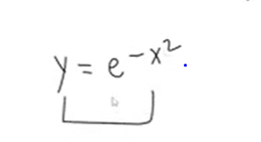

**If we increase x value y value decreases**

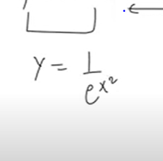

**Standard normal distribution:**

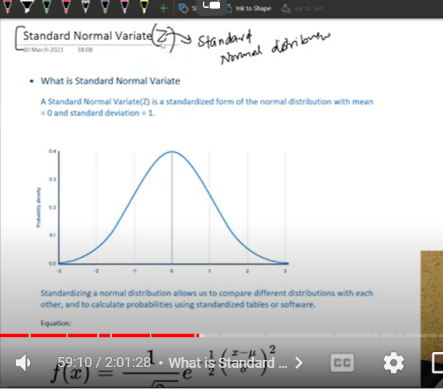

**Special case of normal distribution**

**When mean =0**

**Sd=1**

**Then we can call as standard Normal distribution**

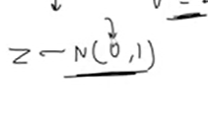

**Adv: allows us to compare diff distributions with each other(if they both follows SND)**

1. **Calculate probabilities using z table**

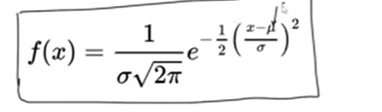

**In this equation**

**Mean=0**

**Sd=1**

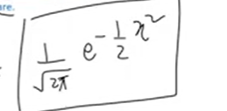

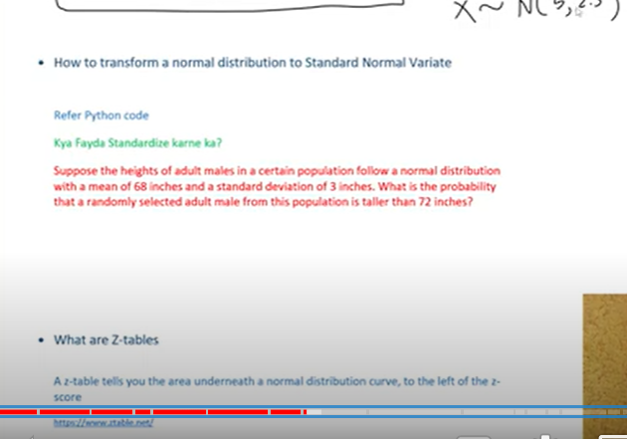

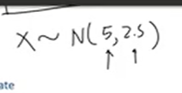

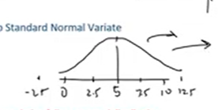

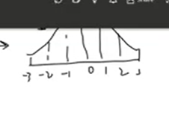

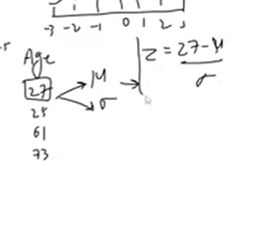

**Scale it with Z value**

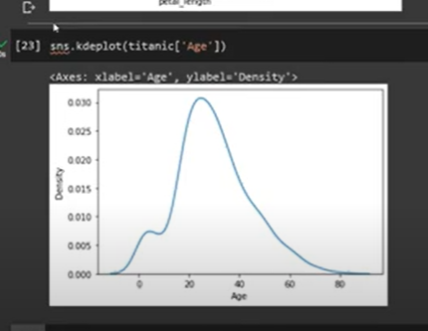

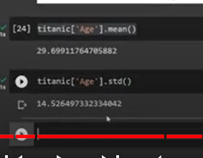

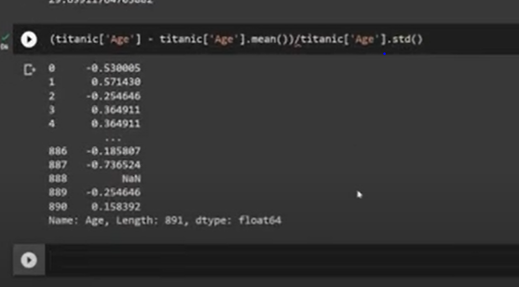

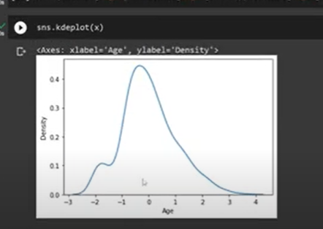

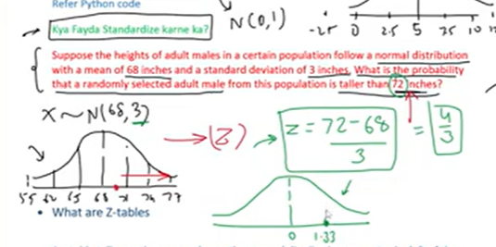

**1.33 is z score**

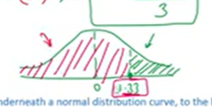

**What is the probability that a value is below 1.33**

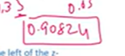

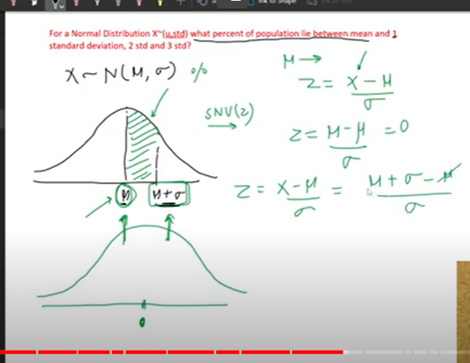

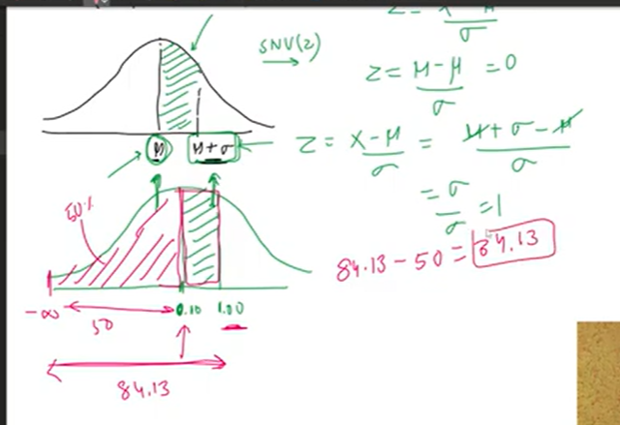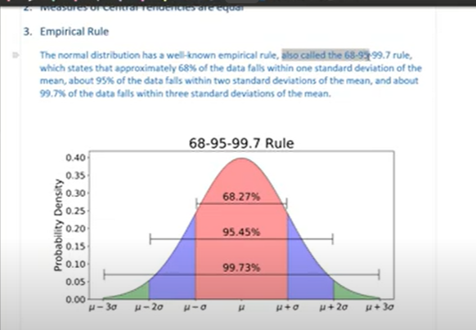

**We derived by using Z table**

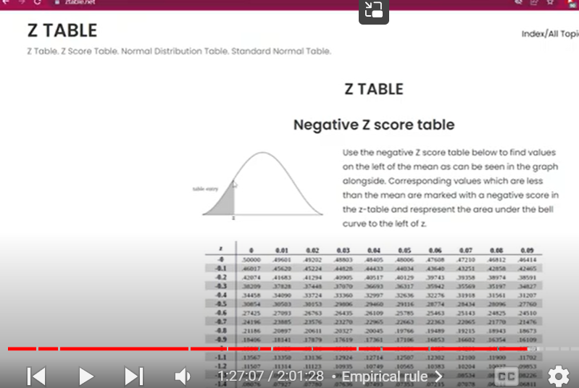

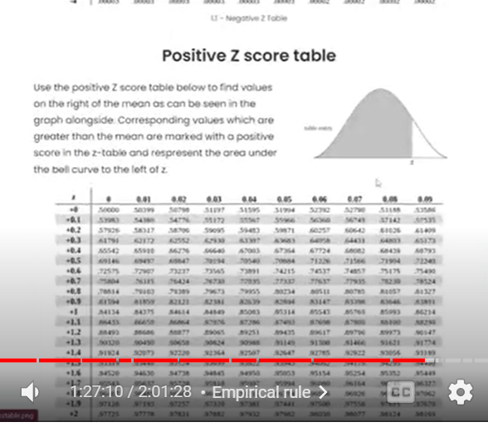

**Z give area till that value**

**Area under that curve**

**Also called probability**

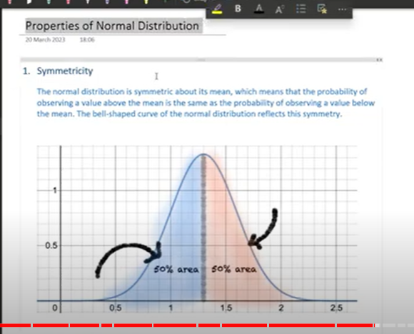

**Symmetric around the mean**

**Mirror image of graph**

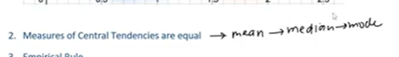

**Mean , median , mode=equal**

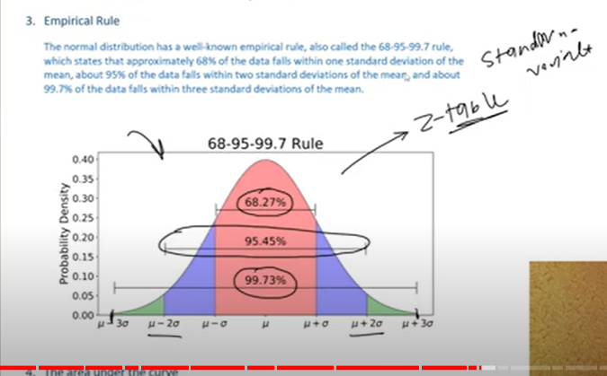

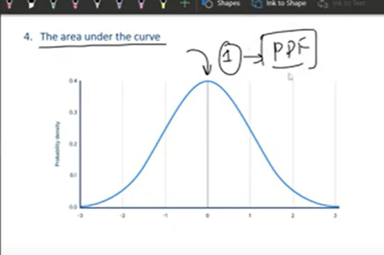

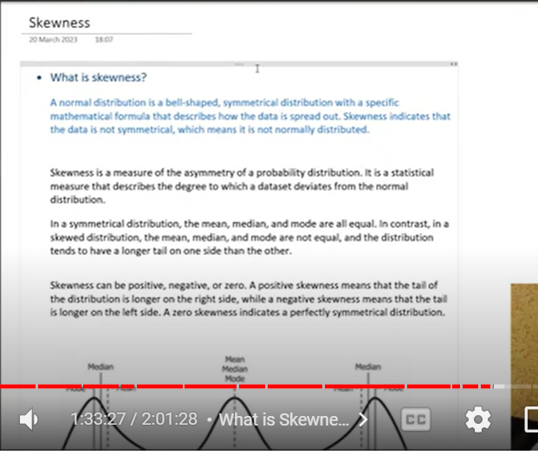

**Skewness – data is not symmetrical – means not normally distributed or non symmetrical**

**Measure of asymmetry of a probability distribution**

**Describe the degree to which dataset deviates from normal distribution**

**Mean, median, mode- not equal**

**Distribution tends to have longer tail on one side than other**

**Skewness – positive, negative 0r zero**

**Positive:tail of distribution longer on right side**

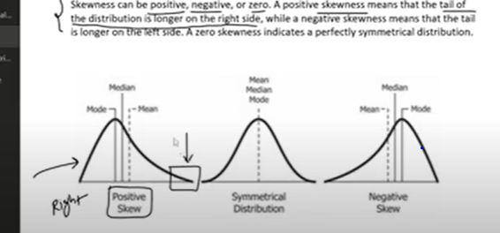

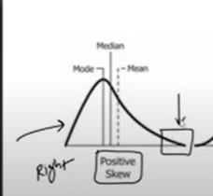

**Much data left side**

**Tail: generally have outliers**

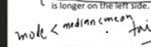

**Left skewed**

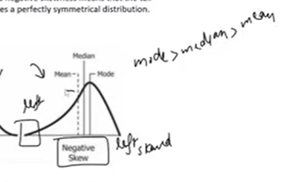

**Greater the skewed – the distance will increase between mean, median and mode**

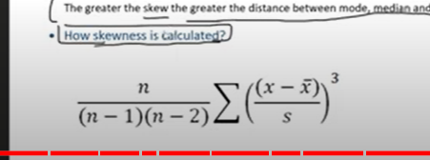

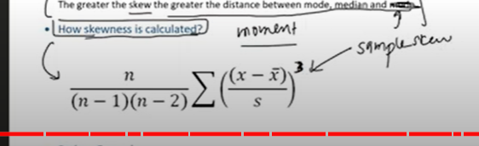

**Movements**

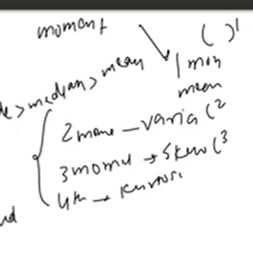

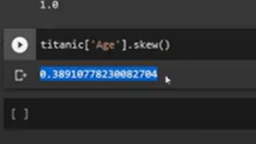

**Near to zero**

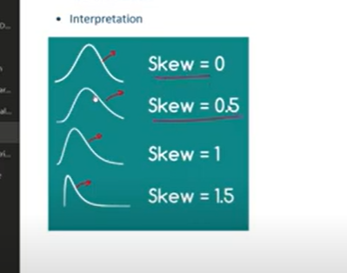

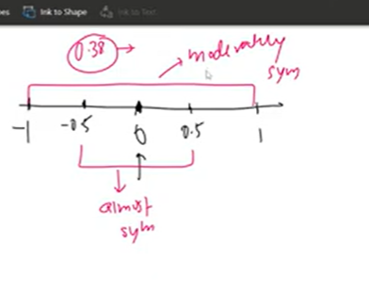

**Above-1 and +1 : highly skewed**

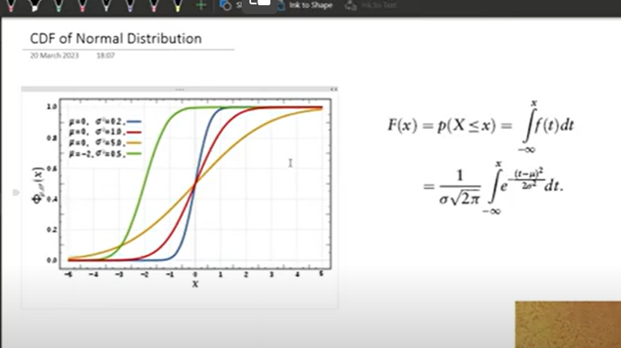

**When Sd increases – graph moves away from center**

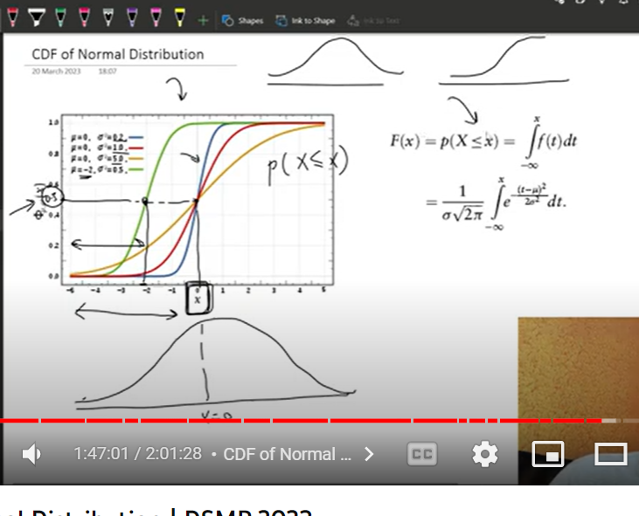

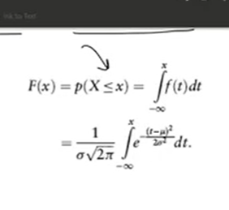

**Integration of pdf gives CDF**

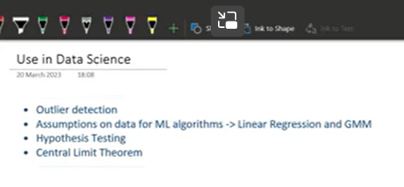

**Above -3,+3 above sd**

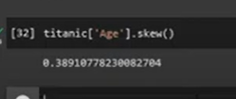

**Age is almost normally distributed**

**Outlier finding:**

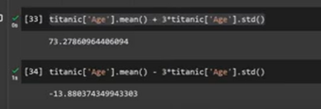



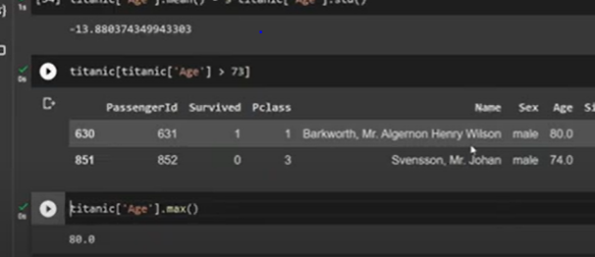

**Many machine learning algorithms :**

**Linear, logistic, guassian mixture: assumption – that data is normally distributed**

**Linear: residual/error**

# Non-Gaussian Probability Distributions

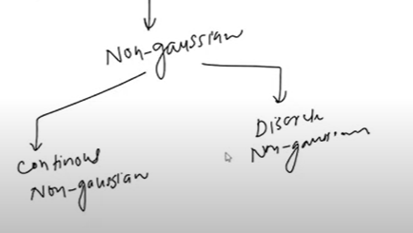

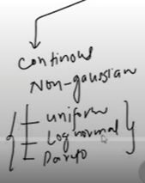

**How can we say given distribution is normal?**

**Q-Q**

**Transformation: to convert non gaussian distribution to gaussian**

**By**

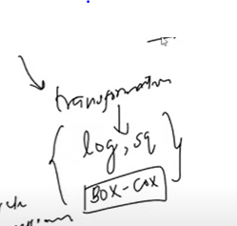

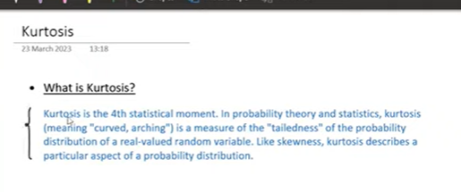

**4th statistical movement**

1. **Movt: mean**
2. **Sd**
3. **Skewness**
4. **Kurtosis**

**Kurtosis- curved , arching**

**Measure of tailed ness of probability distribution**

**Sachin – in 2007 he played 100 matches**

**In all matchs avg40**

**2008 :**

**He changed his tech**

**Played 100 matches**

**Again 40 is mean**

**Both distribution same when we compare mean**

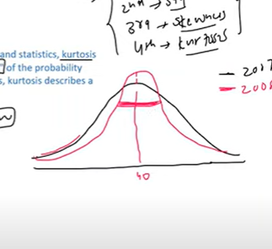

**Mean same sd changed**

**2008 he is more consistent as very less value in – tailed regions**

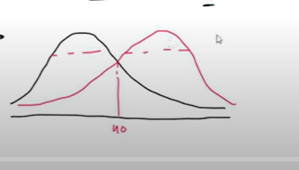

**Mean and sd same**

**But diff is skew**

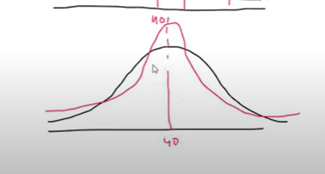

**Mean and sd and skew is also same**

**Diff is fatness of tails**

**Less and more outliers**

**It tells intensity of tailness**

**Density of outlier through fatness of tails – described by kurtosis**

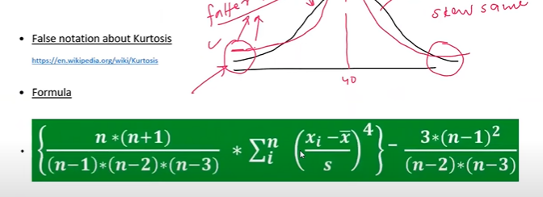

**False: degree of peaked Ness**

**But its – density of outliers**

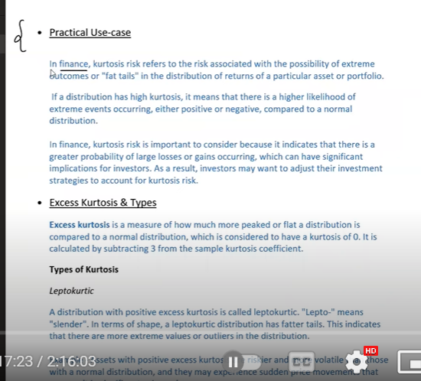

**Finance:**

**Profits in finance**

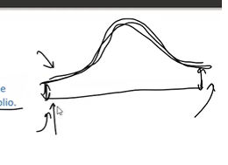

**High fat tails :**

**High profits and loss**

**High volaties**

**High probability of extreme events**

**Greater possibility of loss and profits**

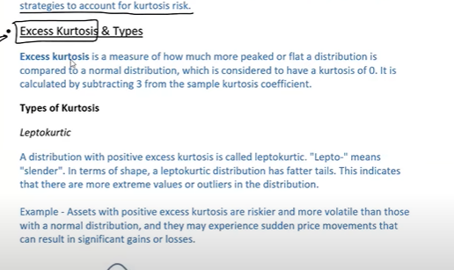

**How much peaked / flat is distribution from normal distribution (where kurtosis =0)\**

**Lepto: positive excess kurtosis**

**Sapmle kurtosis-3>0 then called positive /lepto kurtosis**

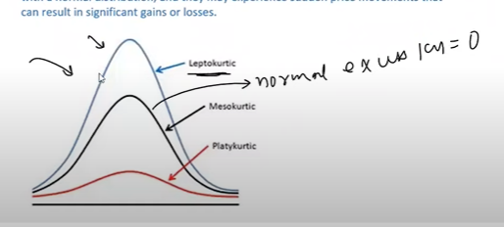**actually mean and sd and skewness is same with normal distribution**

**Fatter tails than ND**

**More outliers**

**Mutual fund- sudden price movements**

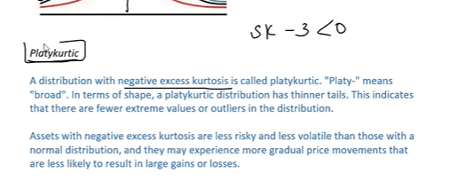

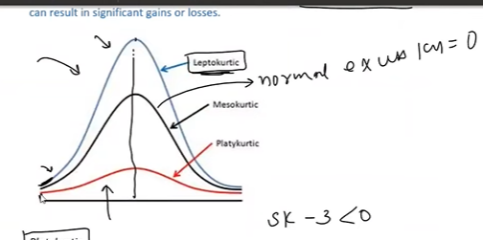

**Thinner tails than ND**

**Fewer extrem values**

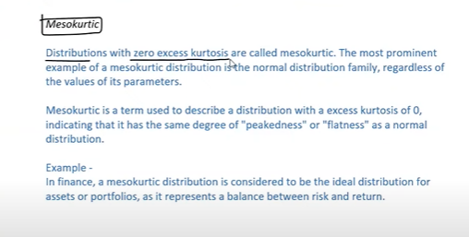

**Meso**

**Normal distribution kind**

**Excess kurtosis =0**

**Balanced mutual funds**

**How to find if given distribution is normal or not?**

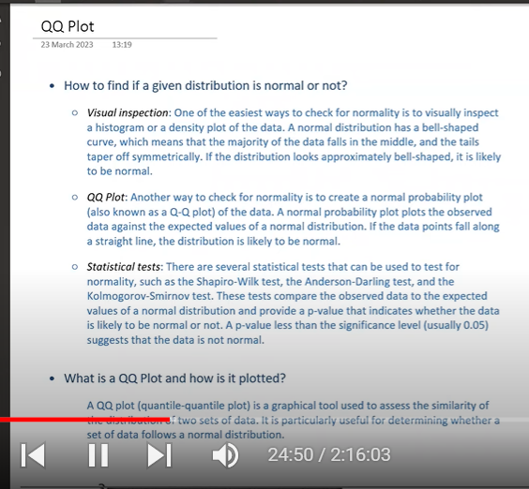

1. **Visual inspection: histogram, density plot**

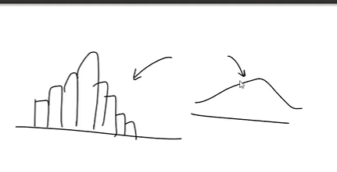

**Q-Q plot(quantile quantile )**

**Statistical test:**

**Q-Q plots:**

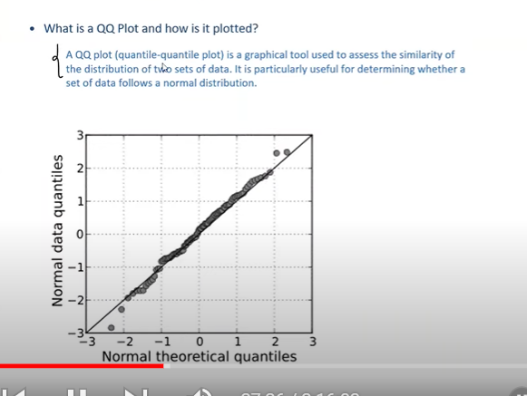

**Assess similarities of distribution of 2 sets of data**

* **Determine set of data follows normal distribution**
* 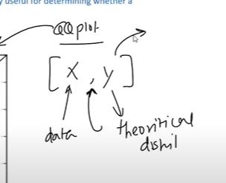
* **Y – normal distributed**

**We compare our data X – with normally distributed one**

**And come to a conclusion wether our data follows ND or not**

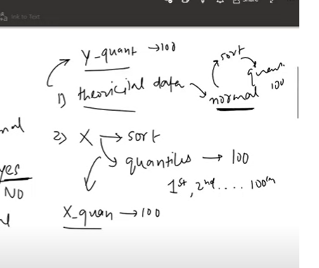

**First calculate quantile for both data**

**And draw scatter plot with their quantiles**

**If all the points comes under same line**

**Then X follows ND**

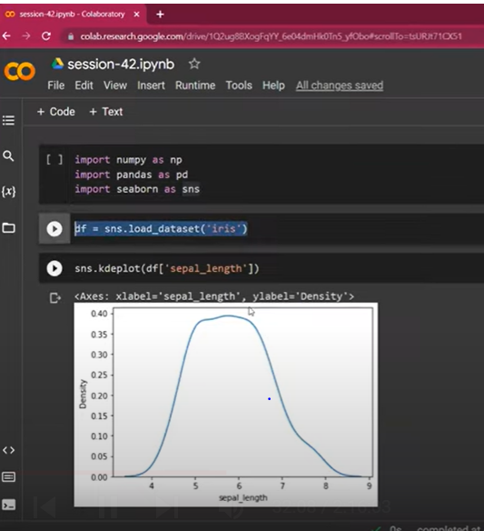

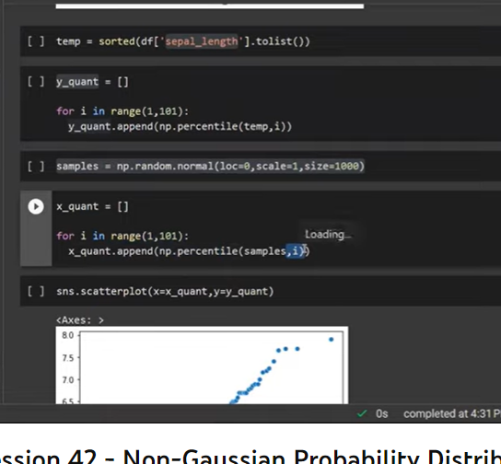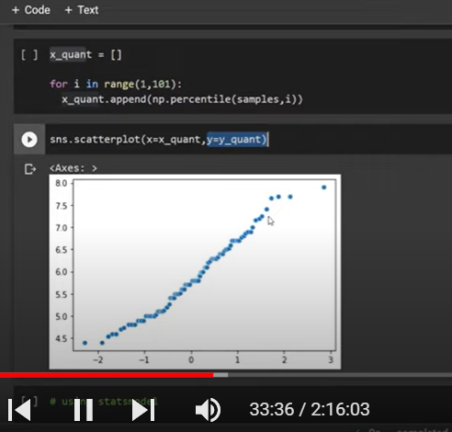

**Sort of normal**

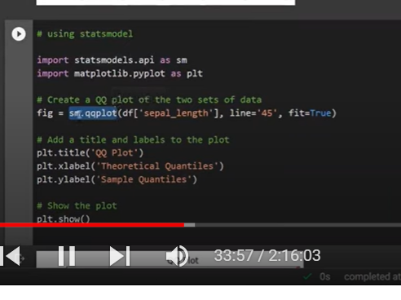

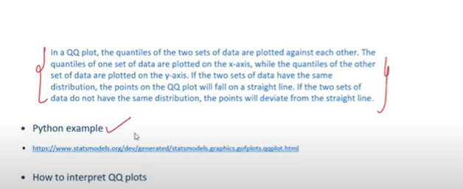

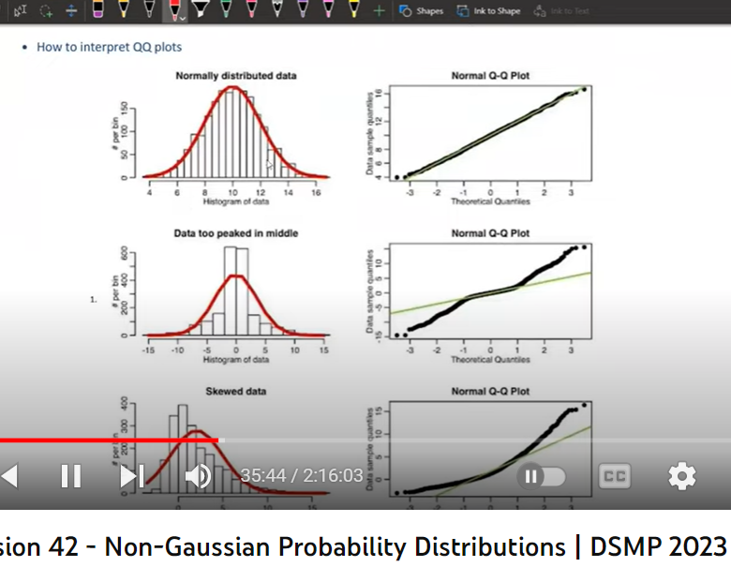

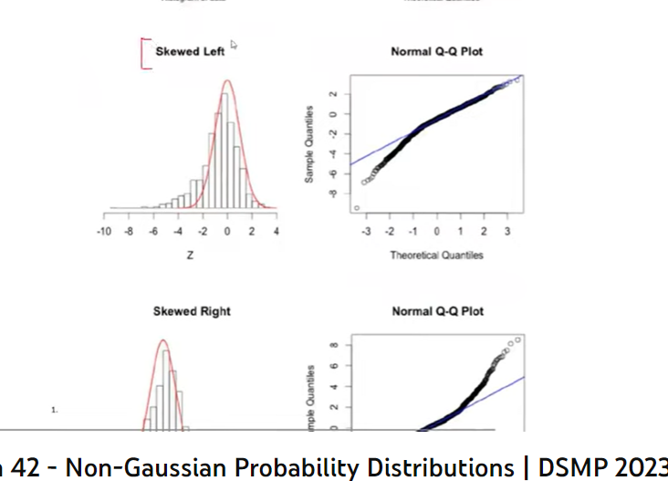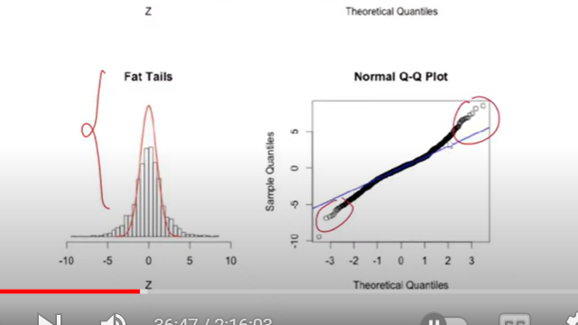

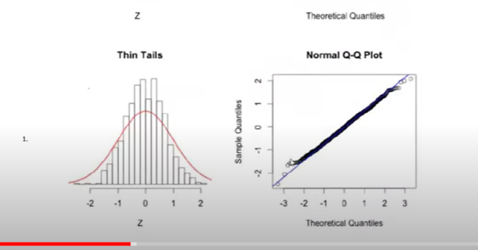

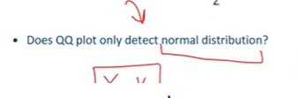

**Detect given distribution ND**

**And also compare two distribution**

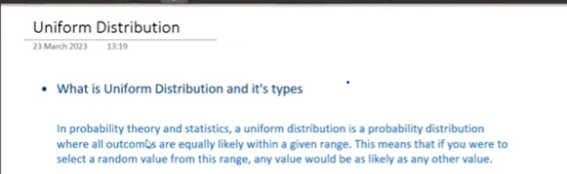

**All outcomes are equally likely within given range**

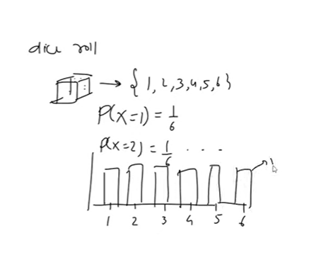

**2 types**

**Discrete uniform distribution**

**Continuous uniform distribution**

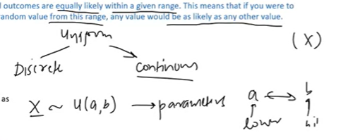

**A= lower value**

**B= higher value**

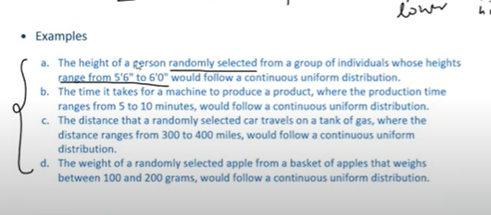

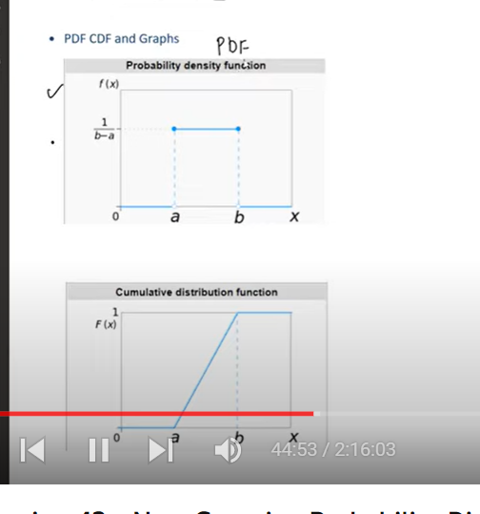

**Given range probability density is constant**

**After that range : probability =0**

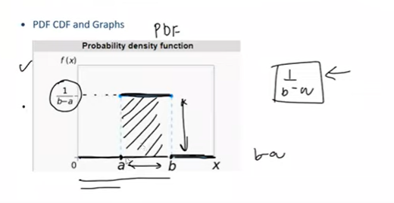

**Take any point: the probability 1/a-b**

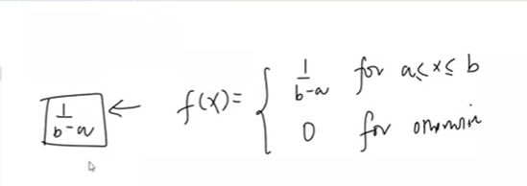

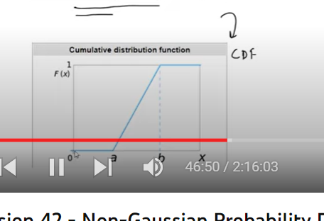

**Skewness of continuous uniform distribution:**

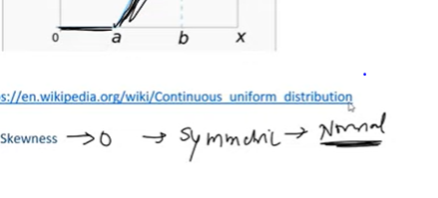

**Unform distribution cases**

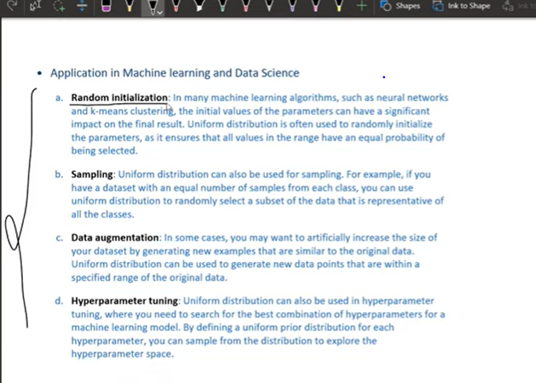

**Radomly initialization of parameters – use uniform distribution- all values have equal probability being selected**

**Sampling:**

**Each class represent equally**

1. **Data augmentation : when data set is not suffient to train model , we create new data from old**

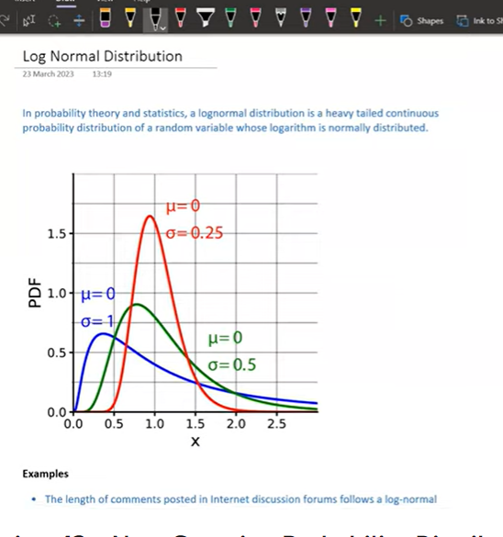

**It is heavy tailed right skewed distribution**

**We cant call all right skewed as log normal distribution only when log(x) is normally distributed**

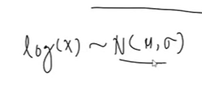

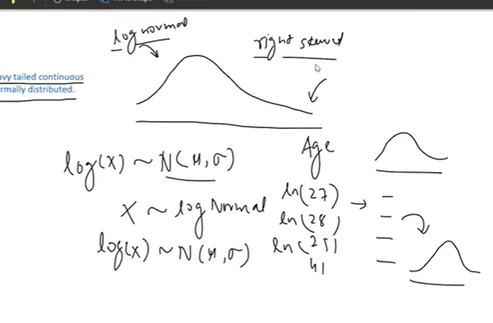

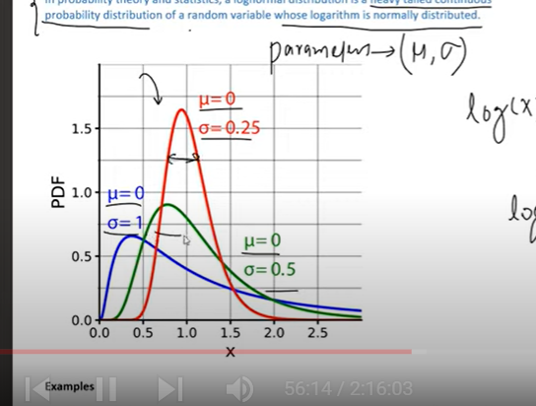

**Where can we see log normal distribution**

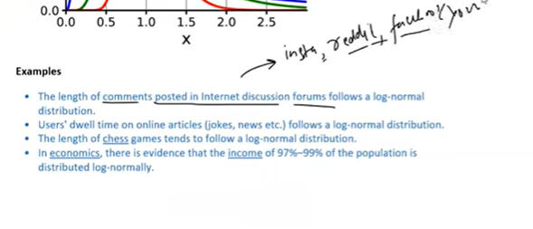

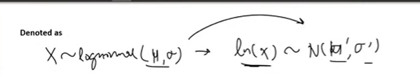

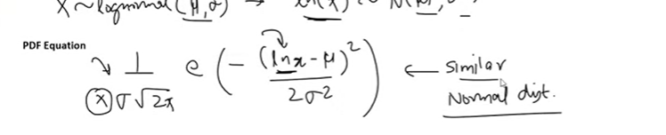

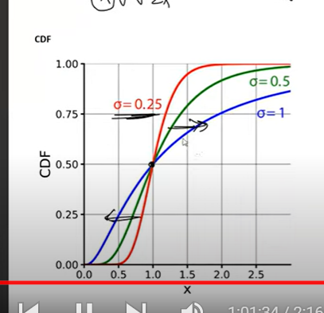

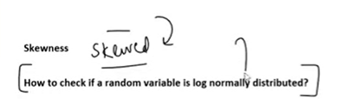

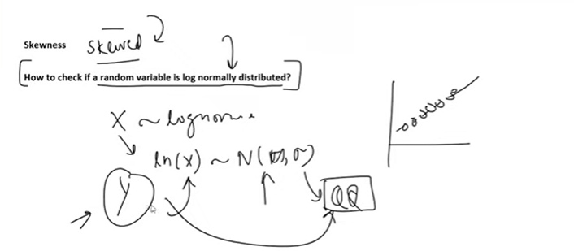

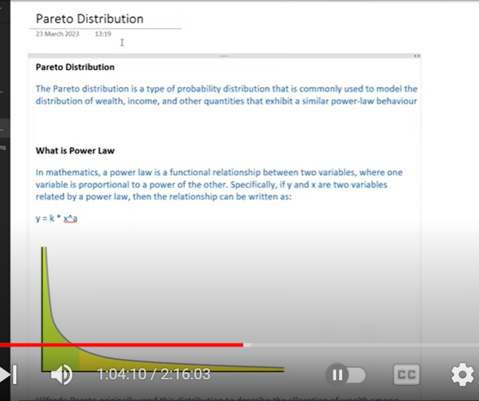

**Can be seen in economic and finance**

**Power-law behavior**

**Power-law: in mathematics, if x and y relation is power law : one variable is proportional to power of other variable**

**80:20 rule**

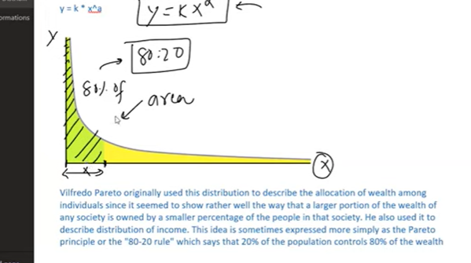

**20 perc of one variable can control 80 per of other variable**

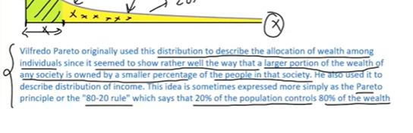

**20 perc of individuals will have 80 percent of wealth**

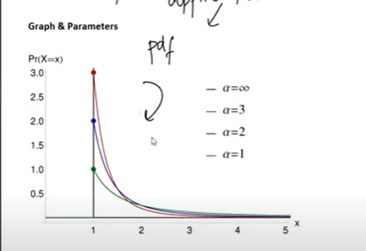

**Only one parameter alpha**

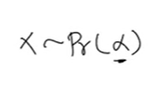

**On y axix – alpha**

**High alpha thin tails**

**Low alpha – fat tails**

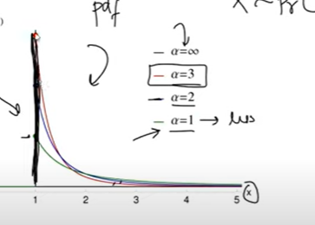

**If alpha is infinity – straignt line on y**

**No such area**

**Y will me max at xm or x starting point**

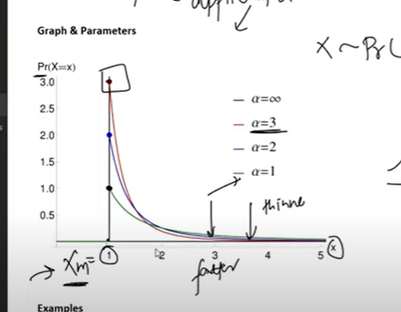

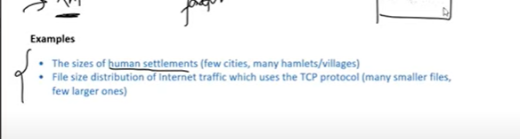

**20 per of area have 80 percent houses**

**File size distribution in internet**

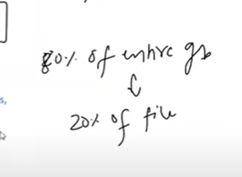

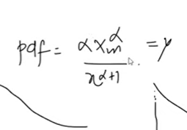

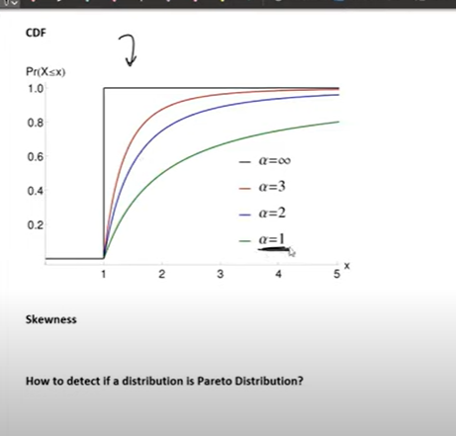

**When alpha =1**

**It takes time to reach x , fat tails**

**When alpha increases (red) reaching x , flat tails**

**Alpha infinity – straight line**

**How to know given distribution is pareto:**

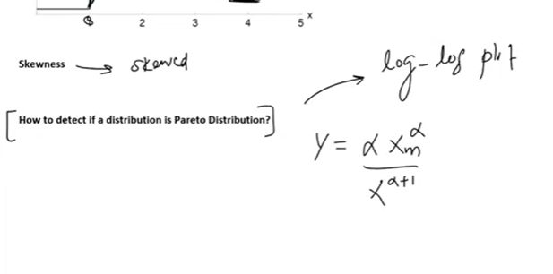

**Take log values of x**

**Log values of y**

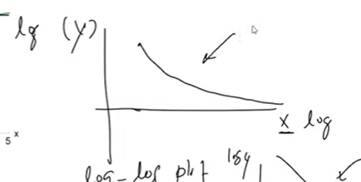

**If u get above graph – pareto**

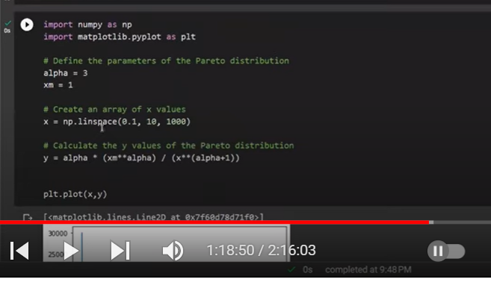

**Q-Q plot**

**Transformations:**

**We need to data to be normally distributed**

**In real word we don’t get data which is exactly like normal distributed**

**We need to apply some mathematical functions to make the data normally distributed**

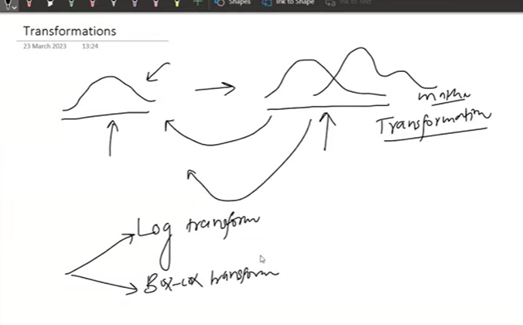

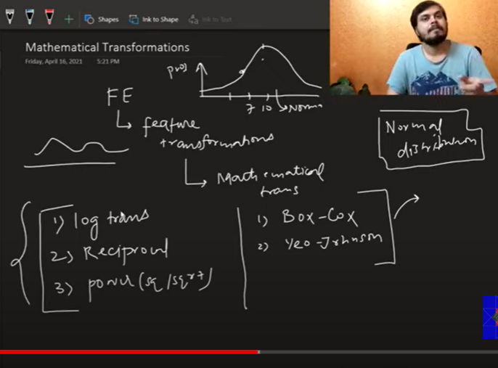

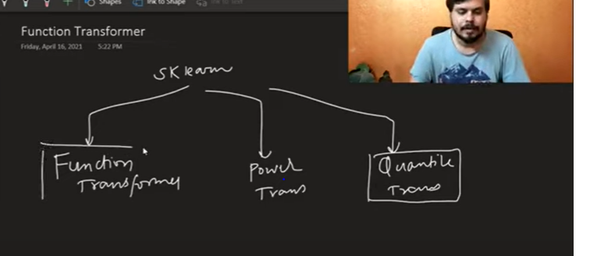

t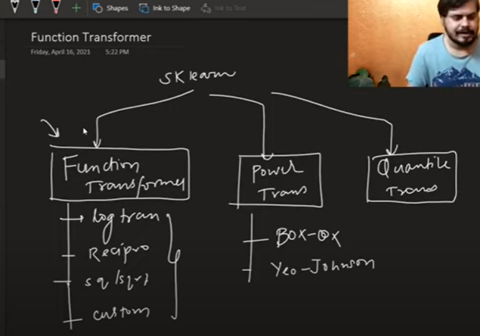

to know if data is normally distributed

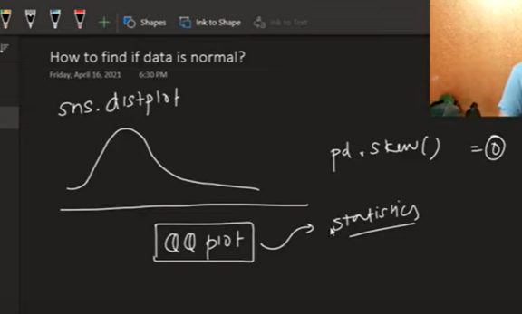

**Log transform: right skewed**

